Grade Book
Design Document

CMSC 420: Group 3

Submitted To :
Dr. Zang

Submitted by:

Brighton Helmke
Christopher Wilson
Joshua Holzbach
Maha Al-Thani
Skyler Stoudt Badreldin Altayeb

1. Introduction

1.1 Purpose

The purpose of this document is to provide a description of the Grade Book. Which is to allow an instructor to record and average students’ grades, and to give each student access via the Internet to his or her own recorded grades and average to date.

1.2 Scope
This software allows the instructor to record and average students’ grades for course he or she is teaching. Also to create the courses themselves. The instructor is able to set up password-protected accounts for herself (designated as the instructor) and each of her students. It gives students access to their grades and average to date.

2. System overview

The project is designed to implement a client-server application using java to store student grades in a database. By creating a course, the instructor would be able to enroll students in the course, edit or change the grading scheme, upload student grades and edit or delete the course. The instructor is able to print a report that shows the student progress report and the grade report. After an instructor creates a class, the students enrolled in the class would be able to view their grades and assignments.

3. System architecture

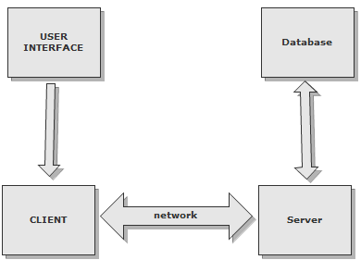
High Level Flow Diagram

3.1 Component design

Person.java
Function
Represents a person whether this person is an administrator, an instructor or a student.

Relationship
The person class contains a list of unique IDs that reference courses.

Methods
getName() - Returns a person's name.
IsInstructor() -Returns true if this person is an instructor
getCourseEnrolled() - Returns a list of the courses the person is enrolled in.
setName() - Sets a variable to a value that represents the name of the person.
SetPassword() - Sets a variable to a value that represents the users password.
SetID() - Takes a string as a parameter and sets the ID of a person to that string. AddCourses() - Takes the course name as a string and add it to the list of person's enrolled courses.
ToString() - Prints the person's name, ID and list of classes if the person is a student.

Roll.java
Function
Represents a roll of persons.

Relationship
The Roll class contains an list of person objects.

Methods
addStudent() - Takes a person entry as a parameter, adds that person to the roll and returns the index where the person was added.
FindStudent() - Takes a person entry as a parameter, search for that person in the roll and returns the index where the person was found.
Size() - returns the size of a roll.

Course.java
Function
Represents a course created by an instructor.

Relationship
The Course class contains a Gradescheme and Gradescale object

Methods
createCourse()- Creates the Course.
getCourseInformation() - Returns relevant course information.
editCourse()- Allows the editing of course information. May be several methods later.

GradingScale.java
Function
Represents the grading scale for each course.

Relationship
The GradingScale class doesn’t reference any other objects

Methods
getcutoffA() - Returns the value that represents the lowest value an 'A' can be.
getcutoffB() - Returns the value that represents the lowest value an 'B' can be.
getcutoffC() - Returns the value that represents the lowest value an 'C' can be.
getcutoffD() - Returns the value that represents the lowest value an 'D' can be.
getcutoffF() - Returns the value that represents the lowest value an 'F' can be.

GradingScheme.java
Function
Describes the grading scheme for homework and quizzes.

Relationship
The Grading scheme class doesn’t reference any other objects.

Methods
CalculateGrade() - Calculates the grade.
GetGrade() - Returns the grade.

SessionManger.java
Function
In charge of forwarding data to the proper classes and returning the results.

Relationship
The SessionManager doesn’t directly manipulate class objects it only forwards them to the client or the database.

Methods
To be designed and created as the project progresses.

Client.java
Function
Communicates with the Session Manager to send and receive data the gui needs.

Relationship
The Client doesn’t directly manipulate class objects it only forwards them to the SessionManager or gui classes.

Methods
To be designed and created as the project progresses.

3.2 User interface

LoginUI
Gets username and password so can verify whether to allow access to system.

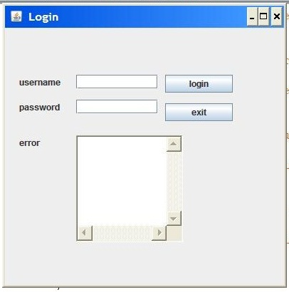
Login User Interface

Components
Username field- Takes in username via keyboard.
Password field- Takes in password via keyboard.
Login button- When clicked sends current text entered in the username and password fields to the server.
Exit button- Exits and stops the client program.
Error text area- Will be updated with text that displays any errors during the login.

SelectOrCreateCourseUI
Allows the user to change password, view courses or create a new course.

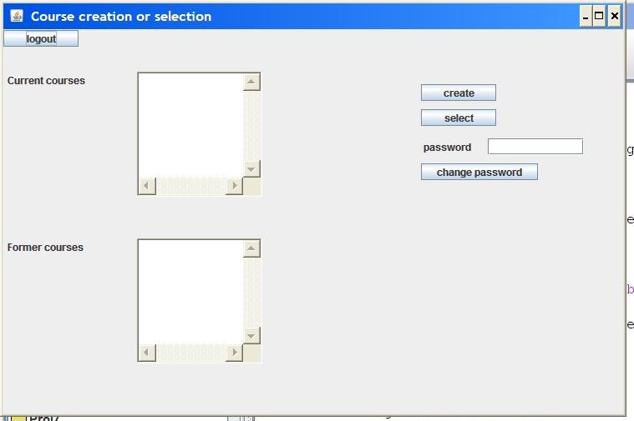
Current Select or Create course UI
Components
Logout button- logs out and opens the login user interface.
Current Courses text area- Contains a list of un-archived courses the student/professor is enrolled in.
Former Courses text area- Contains a list of archived courses the student/professor is enrolled in.
Create button- Opens an interface to create a new course. Appears only on the Admin and instructor accounts.
Select button- For instructors and admins, an Course Options UI is opened. Students will just be taken somewhere to view grades.
Password field- Takes in the users new password.
Change Password button- When clicked it changes the users password to the one in the password field

AssignmentUI (non-student)
Allows Professor or Admin to record grades for a student.
Components
Logout button- logs out and opens the login user interface.
Assignment Name field- Takes in the name of an assignment to be created.
Category field- Takes in the category of an assignment to be created.
Create Assignment button- Initiates the creation of an assignment.
Current Name field- holds the name of the assignment to be edited.
New Name field- holds the new name of the assignment.
Edit Assignment button- The button to change name of the assignment.
Student to record grade for- Takes in the name of student record grades.
Assignment to record grade for- Takes in the name of the assignment
Enter numeric value button- Takes in the value of the grade for the assignment.
Record Grade button- Initiates the recording on a grade.
ManageStudentsUI (non-student)
Add Remove/Students from the course.
Components
To be designed.

GradingSchemeUI (non-student)
Allow the user to create a new grading scheme, modify a scheme or save scheme.
Components
Create Scheme button- allows the creation of a new scheme.
View Scheme button- views the selected scheme.
Select Scheme button- Allows for the selection of a Scheme.

Grading scaleUI (non-student)
Allow the user to create a new grading scale, modify a scheme or save scheme.
Components
Create Scale button- allows the creation of a new scheme.
View Scale button- views the selected scheme.
Select Scale button- Allows for the selection of a Scheme.

ReportsUI (non-student)
Display generated reports.
Components
View reports button- opens a report.

AdminUI (non-student/non-instructor)
Allows an admin to select a course, change users passwords, add/ remove people from being able to access the system.
Components
Create course button- Allows for the creation of a course
Change password button- Initiates password change.
Select Course button- Goes to selected course.
Remove Course button- Removes the course from the list.
Users information- View User information.

CourseOptionsUI (non-student)
Allows an instructor to edit the grading scale, edit the grading scheme, add/remove students from a course and record grades. It allows students to view their grades.

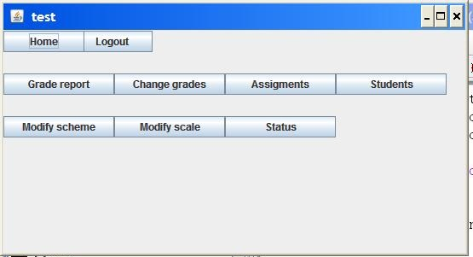
Current Course Options Interface
Components
Home button- Students and instructors are returned to the select course UI. Admins are returned to Admin UI.
Logout button- Logs out and opens login UI.
Grade Report button- Instructors and Admins will see a UI with all the students.
Change Grades button- Removed in current version.
Assignments button- Opens UI to manage Assignments.
Students button- Opens ManageStudents UI.
Modify Scheme button- Opens GradingScheme UI.
Modify Scale button- Opens GradingScale UI.

3.3 Database
Function
To store and retrieve data to build classes, so class objects can be stored in a non-volatile way. Each box represents a individual table that stores class objects. Every class object is callable by a unique id created when it is inserted into the database.

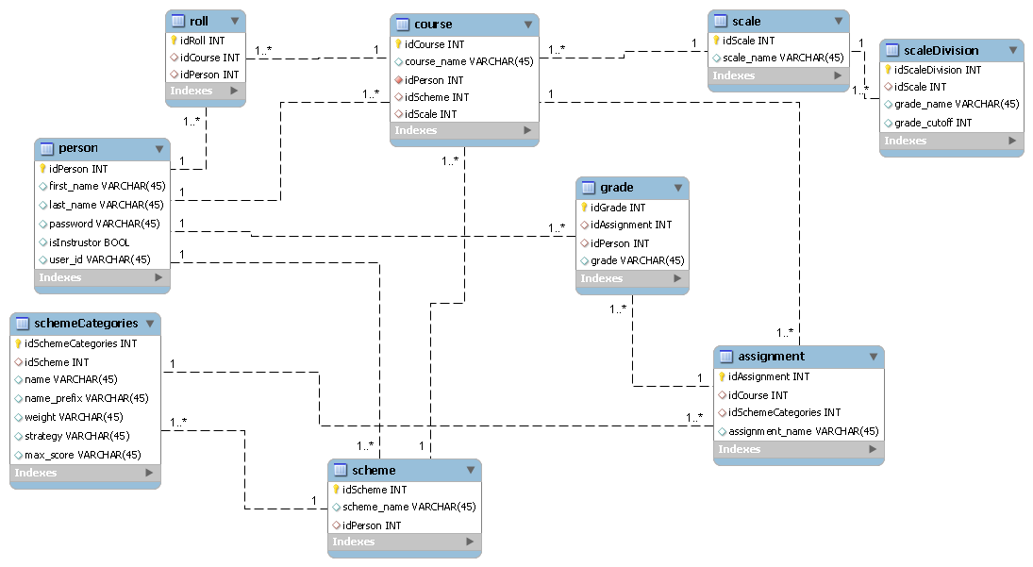
Diagram of the Database

